1 ReactJS-HOL-HANDS-ON-ANSWERS
Installing the Create-react-app by the following command in the command prompt as show in the window snippet below:

Next, we create the React application using the following command –

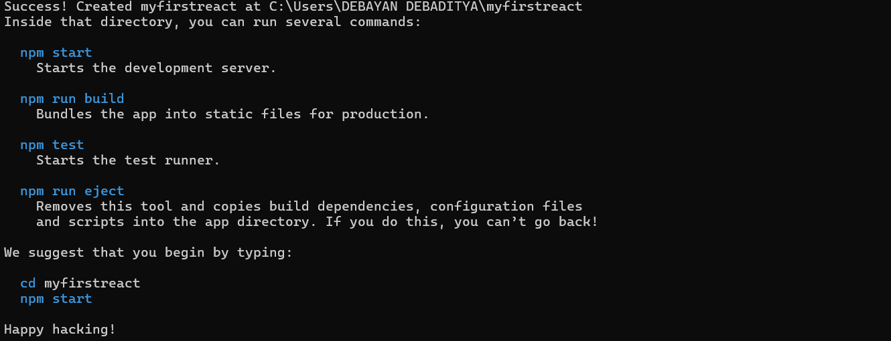
After the creation the output is shown –

Upon the creation of ‘myfirstreact’ the above message was displayed. And then we navigate to the app folder as,

Then we open the folder in VS Code and open the App.js file in Src Folder of myfirstreact and replace its content with the following code snippet shown below –

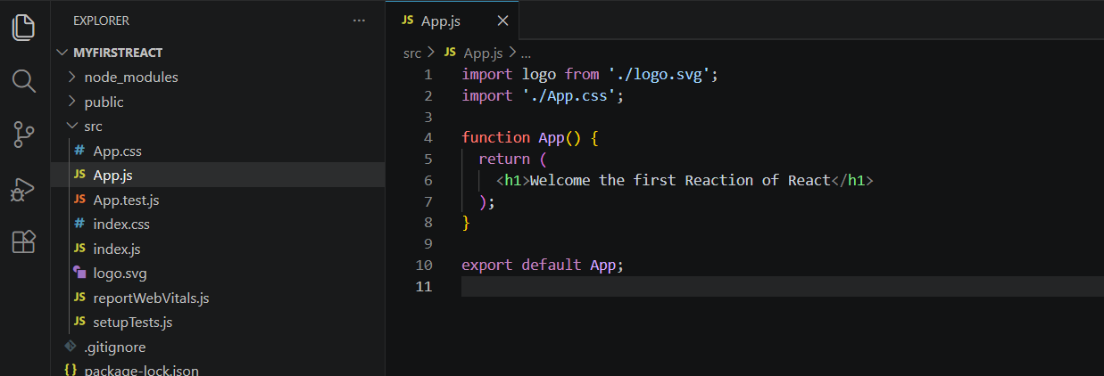
After that, we run the command –
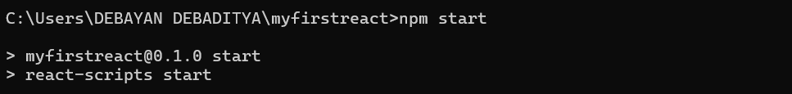

This is the output that we get in the chrome browser as it opens in the localhost:3000
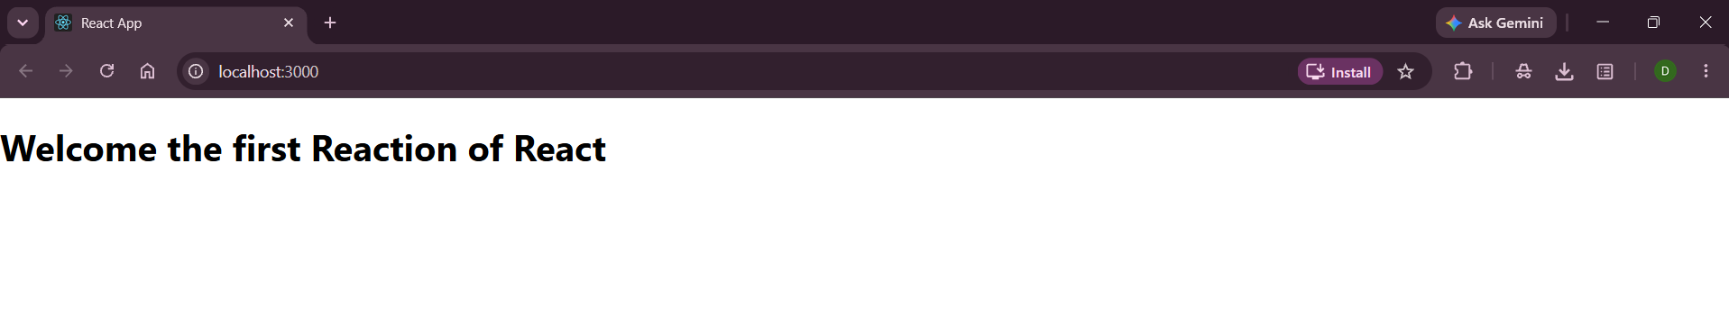
That is what we learn throughout this hands-on.

